DC assignment 2
Case: An e-commerce platform experiences latency during flash sales.
How can distributed caching and load balancing improve performance?
What consistency model would you choose for inventory updates?
Shwen Coutinho(9881)
Aryan Daripkar(9882)
Jonathan Gomes(9900)
Mark Lopes(9913)
Vivian Ludrick(9914)
Mrugank Worlikar(9938)
Aryan Daripkar(9882)
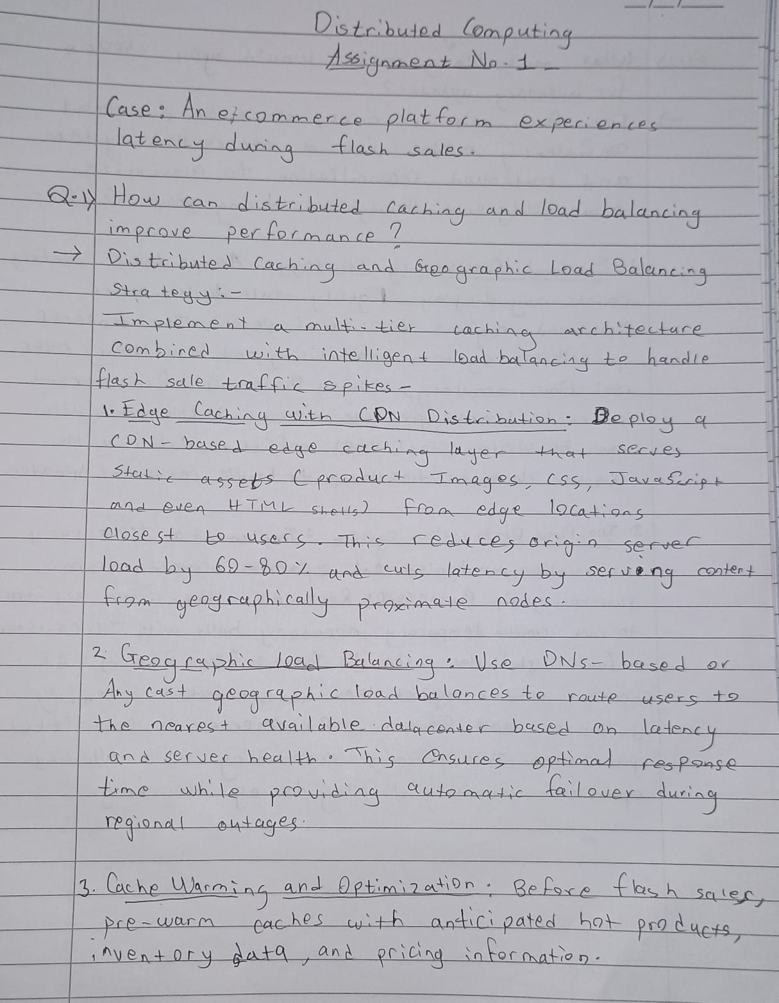
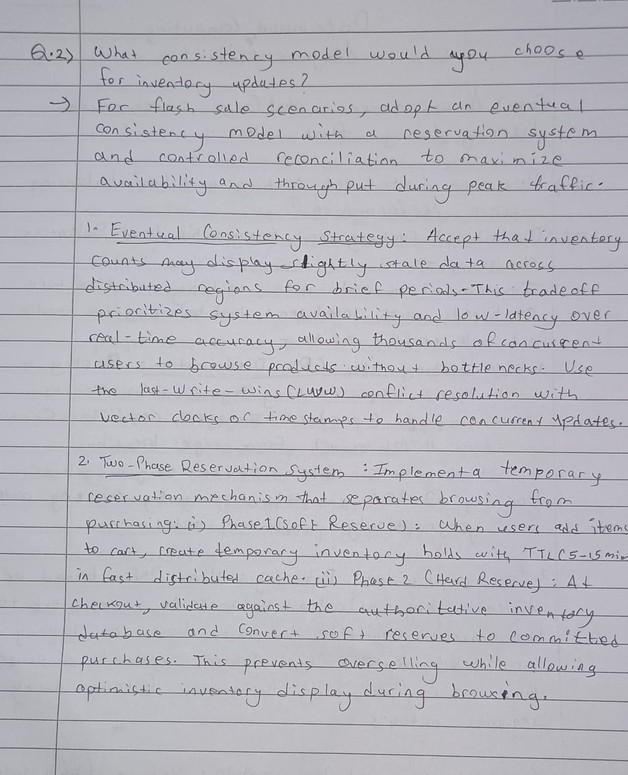

Mark Lopes(9913)
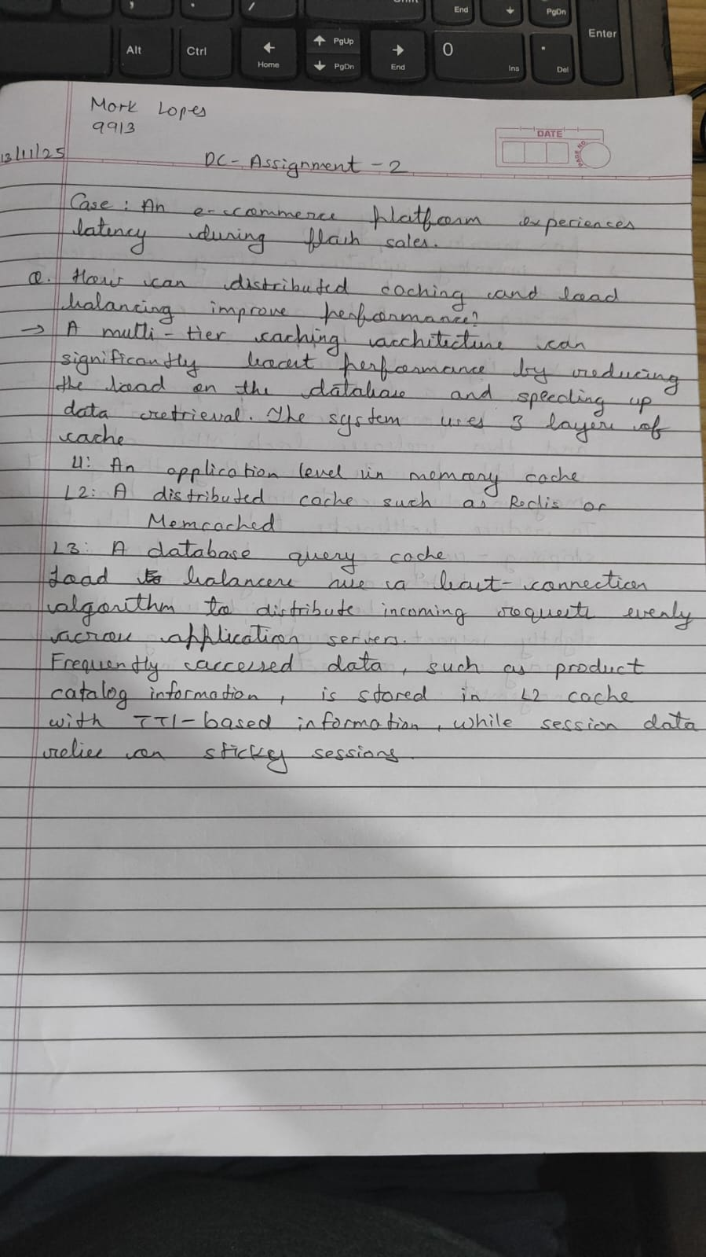
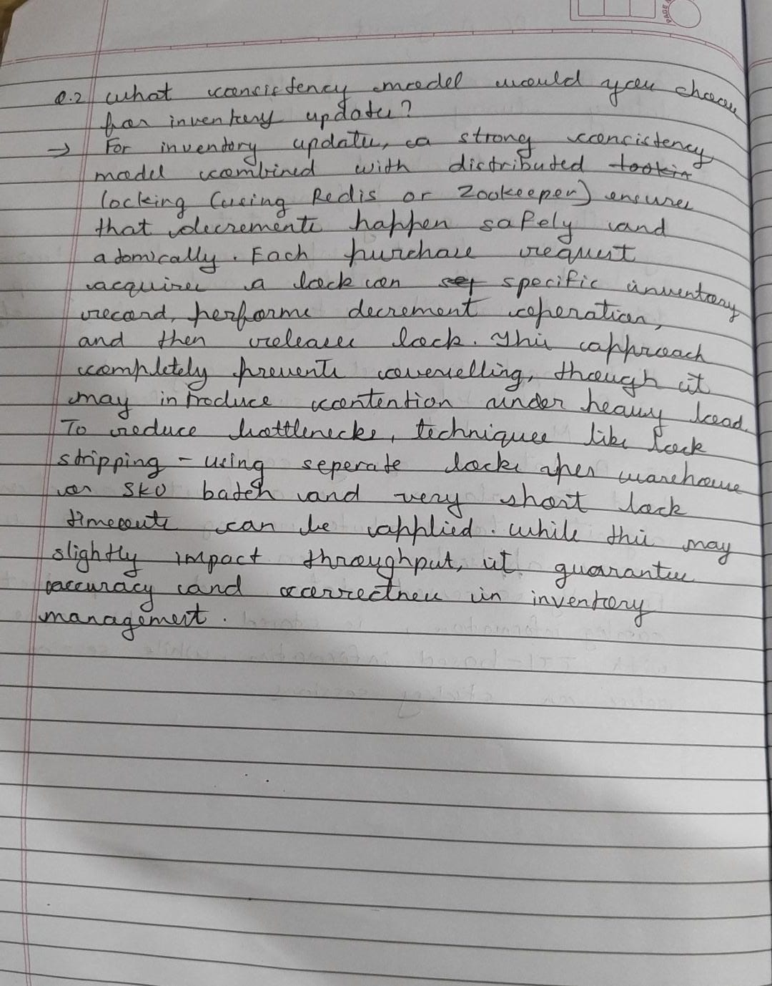

Jonathan Gomes(9900) 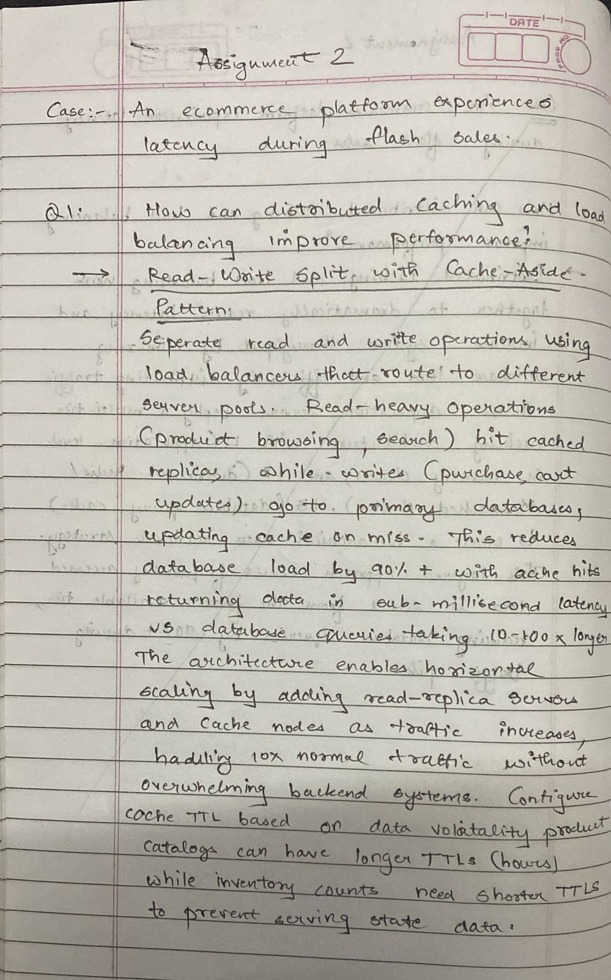
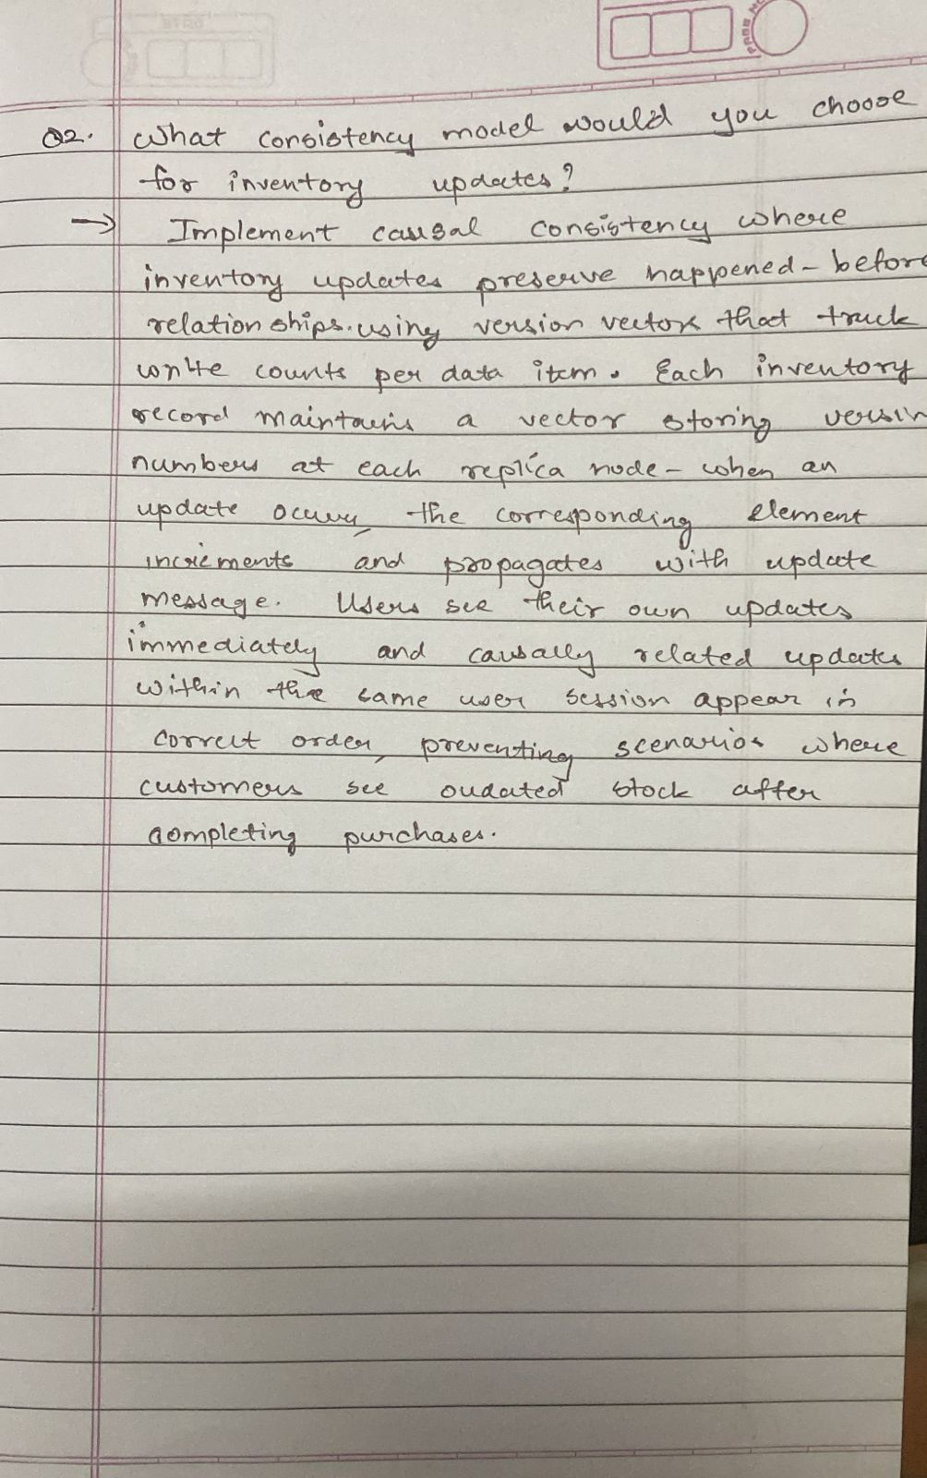 Mrugank Worlikar(9938) 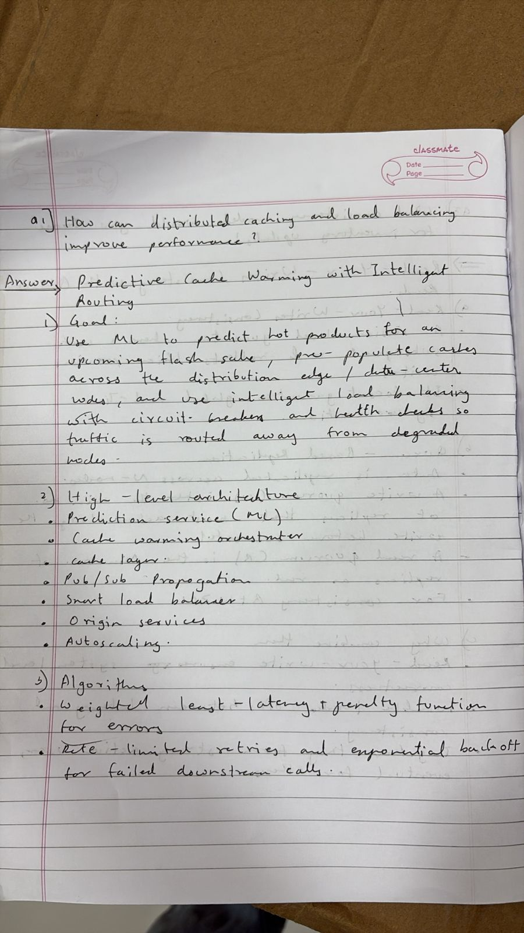
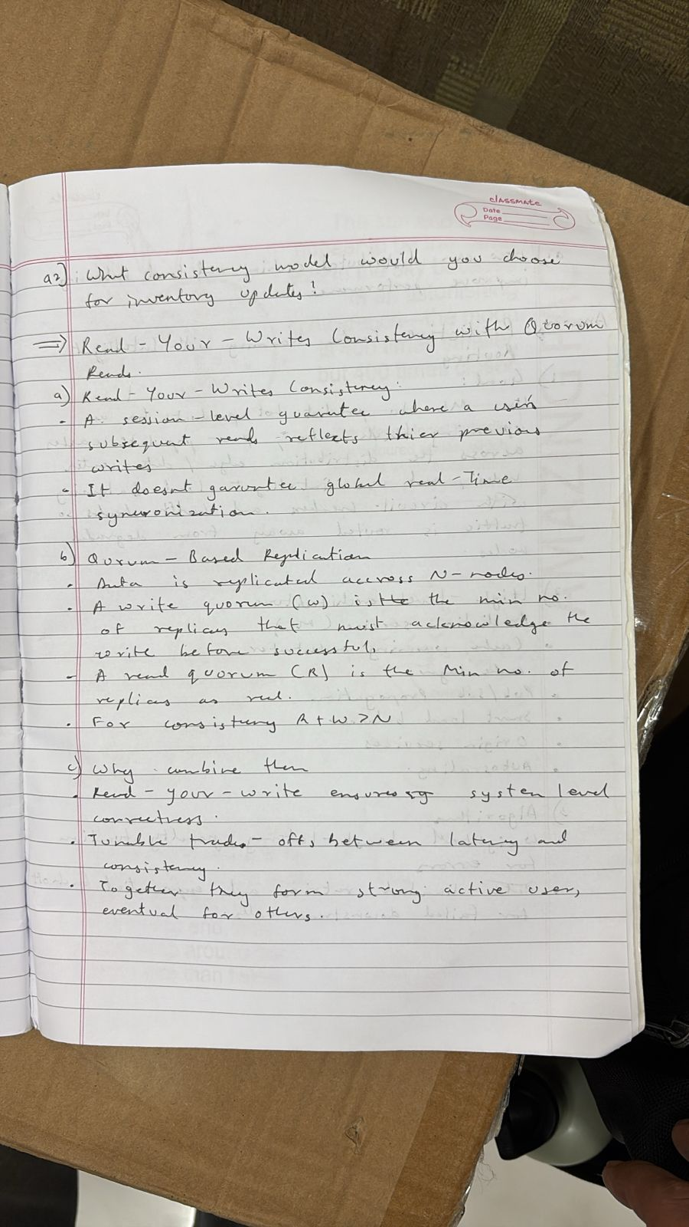
Vivian Ludrick(9914)
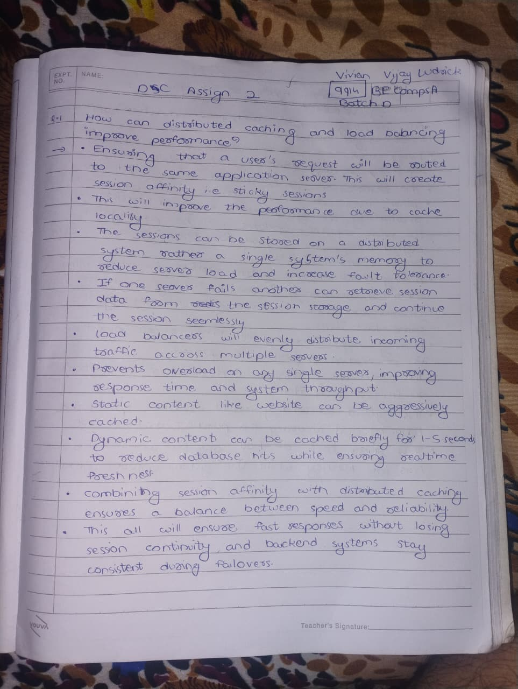

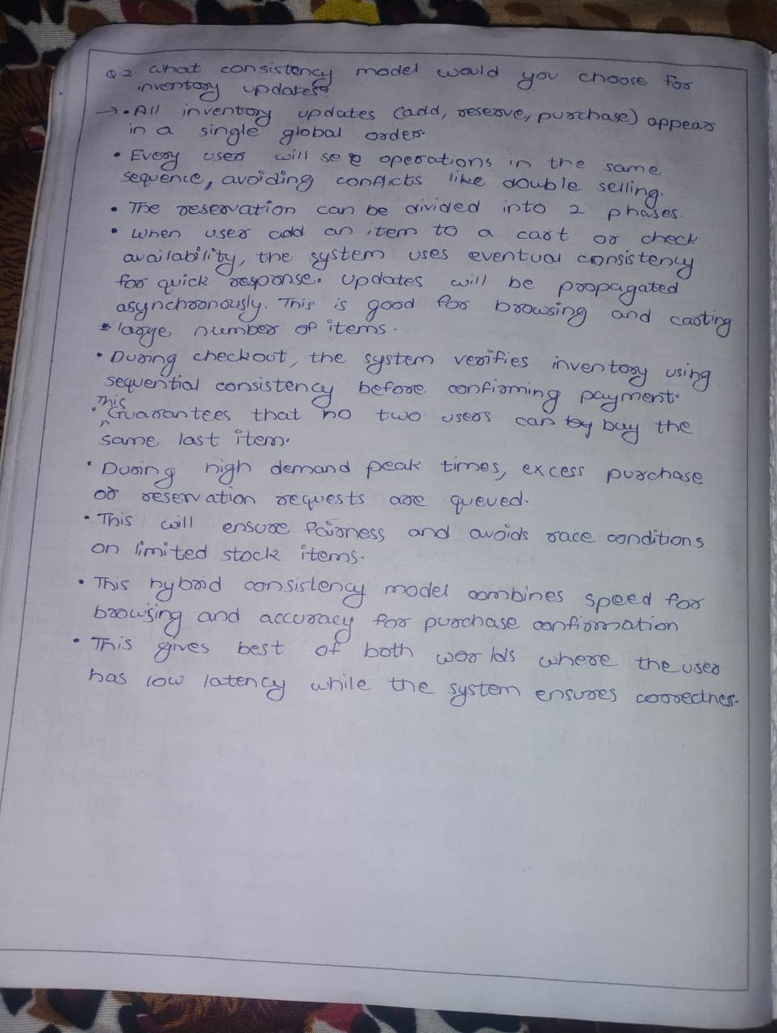

Shwen Coutinho(9881) 